EXPERIMENT 2   
  
  
 **AIM** : To implement python program for visualising the time series room temperature dataset.  
  
**CODE** :   
  
import pandas as pd

import matplotlib.pyplot as plt

import seaborn as sns

# Load dataset

file_path = '/mnt/data/MLTempDataset.csv'

data = pd.read_csv(file_path)

# Convert 'Datetime' to pandas datetime format

data['Datetime'] = pd.to_datetime(data['Datetime'])

# Plot 1: Line plot of room temperature over time

plt.figure(figsize=(12, 5))

plt.plot(data['Datetime'], data['DAYTON_MW'], color='orange')

plt.title('Room Temperature Over Time')

plt.xlabel('Time')

plt.ylabel('Temperature (°C)')

plt.xticks(rotation=45)

plt.show()

# Plot 2: Scatter plot of room temperature

plt.figure(figsize=(12, 5))

sns.scatterplot(x=data['Datetime'], y=data['DAYTON_MW'], color='blue', s=10)

plt.title('Scatter Plot of Room Temperature')

plt.xlabel('Time')

plt.ylabel('Temperature (°C)')

plt.xticks(rotation=45)

plt.show()

# Plot 3: Histogram of room temperature values

plt.figure(figsize=(8, 5))

sns.histplot(data['DAYTON_MW'], bins=30, kde=True, color='purple')

plt.title('Distribution of Room Temperature')

plt.xlabel('Temperature (°C)')

plt.show()

# Plot 4: Box plot to observe temperature distribution

plt.figure(figsize=(6, 5))

sns.boxplot(data=data, y='DAYTON_MW', color='green')

plt.title('Box Plot of Room Temperature')

plt.ylabel('Temperature (°C)')

plt.show()

# Plot 5: Bar plot for sample points (aggregated weekly mean temperatures)

data.set_index('Datetime', inplace=True)

weekly_data = data['DAYTON_MW'].resample('W').mean().reset_index()

plt.figure(figsize=(10, 5))

sns.barplot(x='Datetime', y='DAYTON_MW', data=weekly_data, color='skyblue')

plt.title('Weekly Average Room Temperature')

plt.xlabel('Week')

plt.ylabel('Temperature (°C)')

plt.xticks(rotation=45)

plt.show()

**OUTPUT** :   
  
 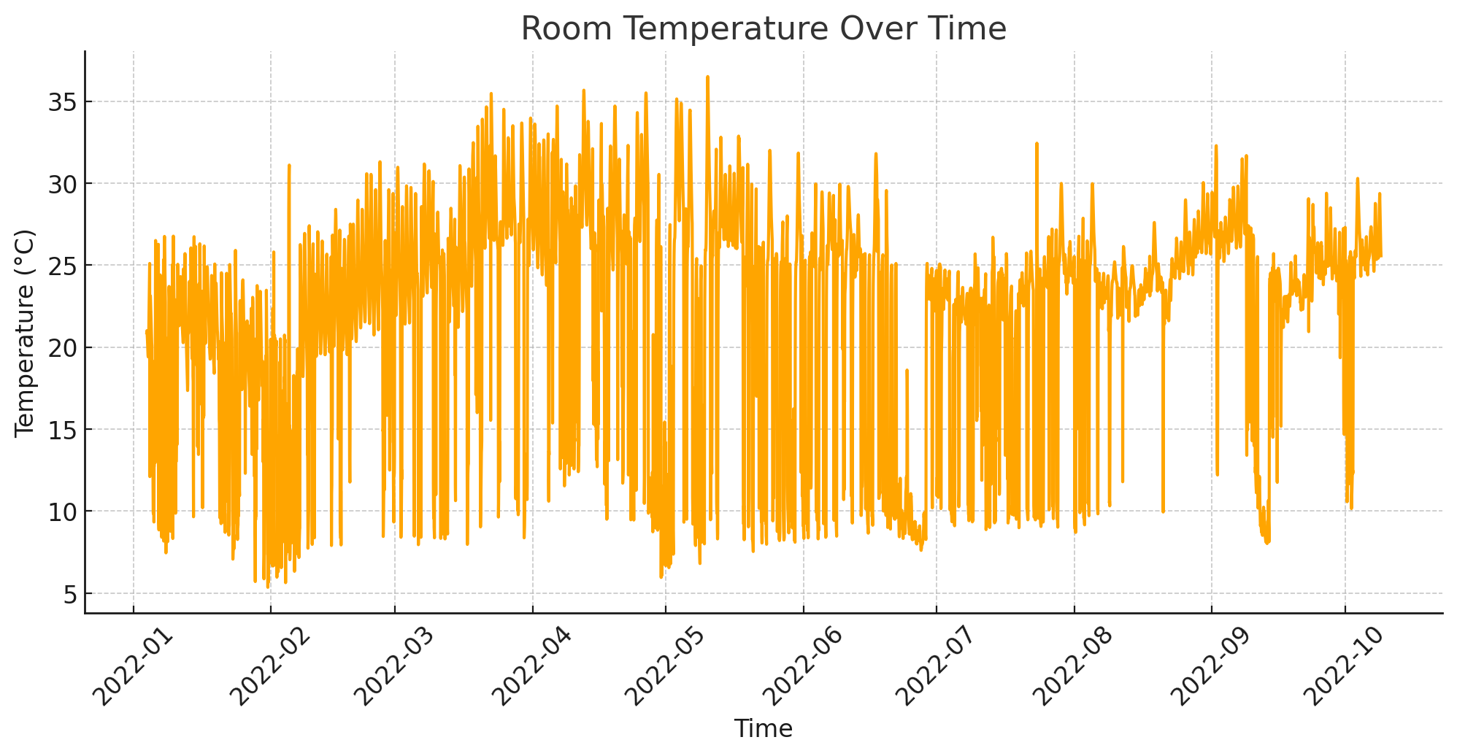  
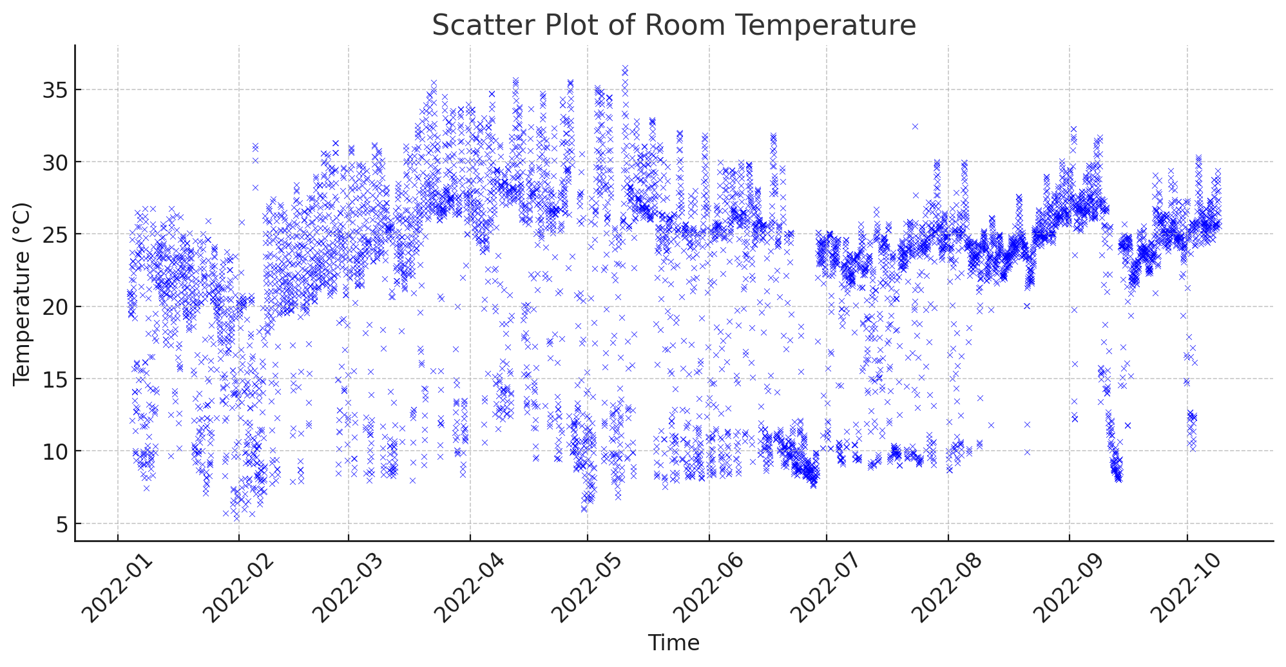  
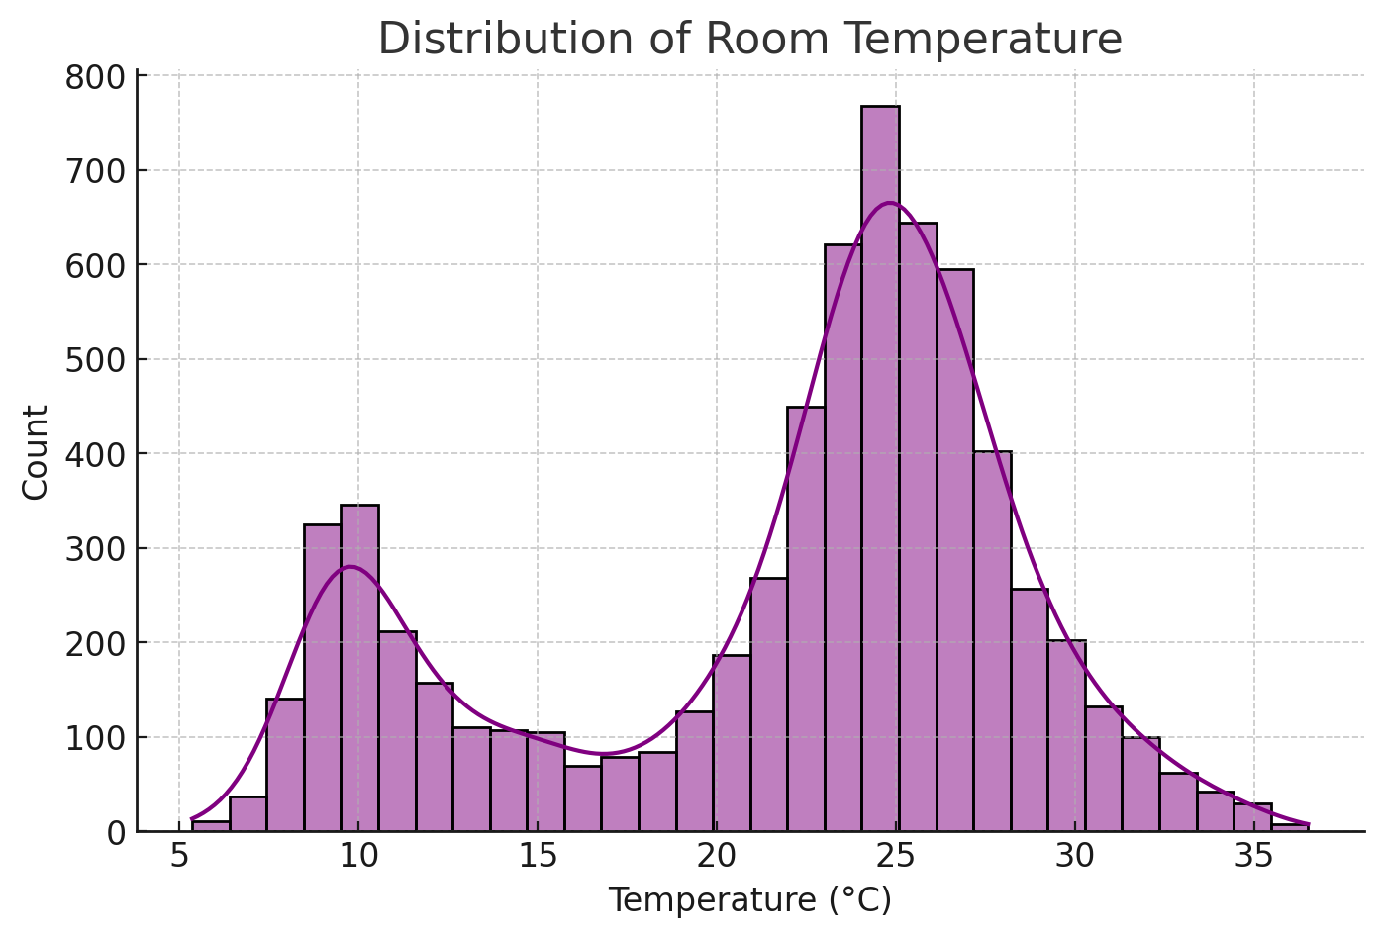  
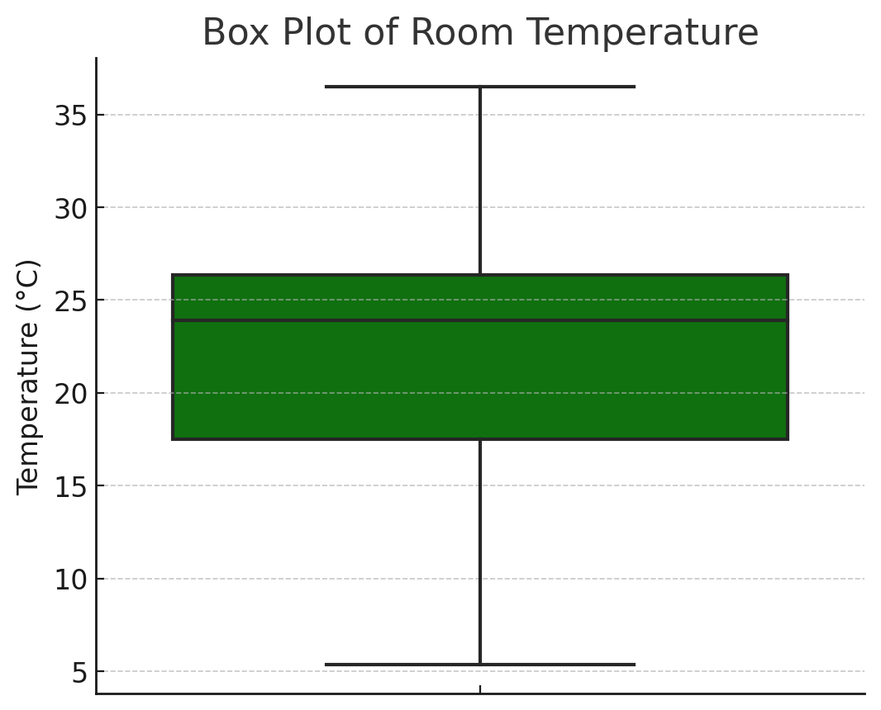  
  
  
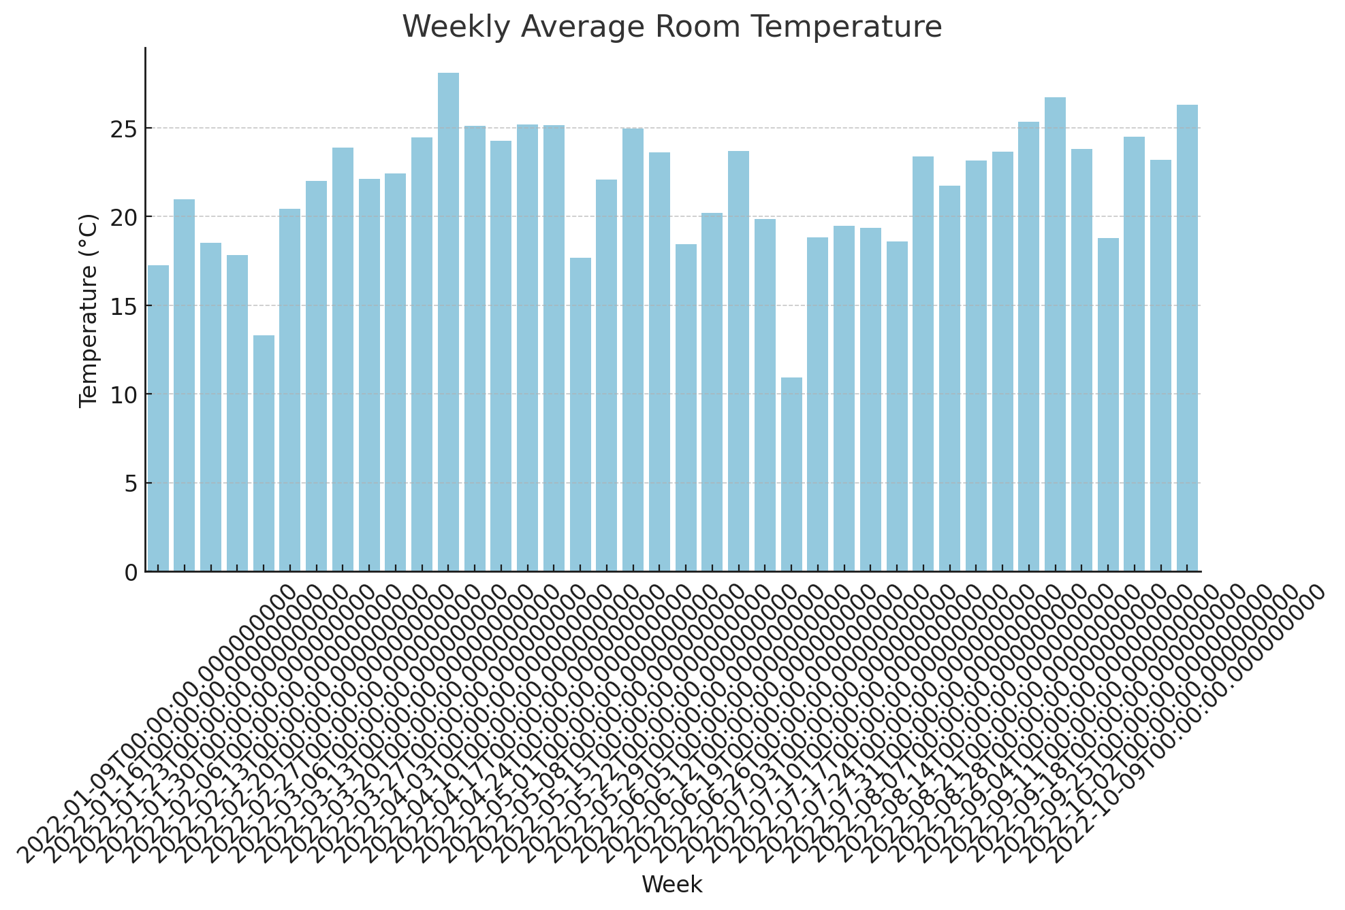  
  
  
  
**RESULT** :   
 Thus the program for visualization of time series dataset is implemented successfully.